**Best Location to Build an Apartment**

Diemas Aksya Fachriza

January 30, 2019

1. **Introduction**

Bandung is one of the most populous city in Indonesia, with 2.575 million population and 15,342 people per square kilometer. The area of this city is 167.7 square kilometers [1]. Fortunately, with such a high population density, the quality of residence in Bandung City also becomes better over time, according to Public Relations of Bandung City.

Despite the quality of residence becomes better, Bandung City has a very high population growth over time. It is predicted to reach 3 million population on the future 10 years [2]. To suppress this problem, when it comes to a population to land size proportion, an apartment would be the best, as it uses much smaller land size than the others such as housing. But, building an apartment isn't easy. We need to consider which is the best place to build it, how many facilities would be available near that place, how hard it is to build it in that place, and so many more to consider.

For this analysis, I'll choose what venues available on that sub-district such as malls, schools, facilities, and the others. The final insight I'll give wouldn't be the exact location, but the best sub-district to build an apartment.

1. **Data Description**

There are a few data that could be used to overcome this problem, which are :

* **Foursquare API** to get the information of venues location (facilities , malls, and schools, and the others) [3].
* **Open Data Bandung City** data about the population density on each sub-district [4].
* **DistancesFrom** to find the center on each sub-district [5].

After getting those data, the DistancesFrom data and Open Data Bandung City data need to be merged first into the following table.

Table 1 Sub-district Data

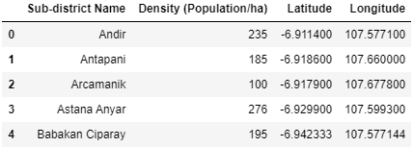

The Foursquare API data need to be acquired first through its API. This contains the venues data on every sub-district. Here is the data acquired from the API.

Table 2 Venues Data

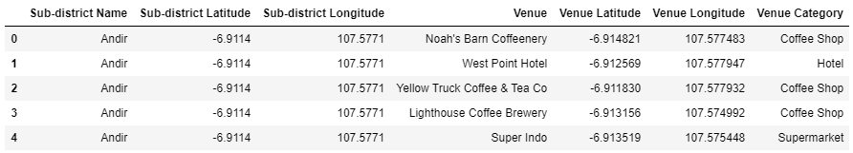

Foursquare API returned 719 venues within 750 meters from the center of each sub-district available in Bandung City. There is one venue category which is not needed for an apartment, which is Hotel. Therefore, the amount of venues returned are 669 venues.

1. **Methodology**

The location dataset on OpenData Bandung City data and DistancesFrom data visualized with Folium to see the geographical condition in Bandung City

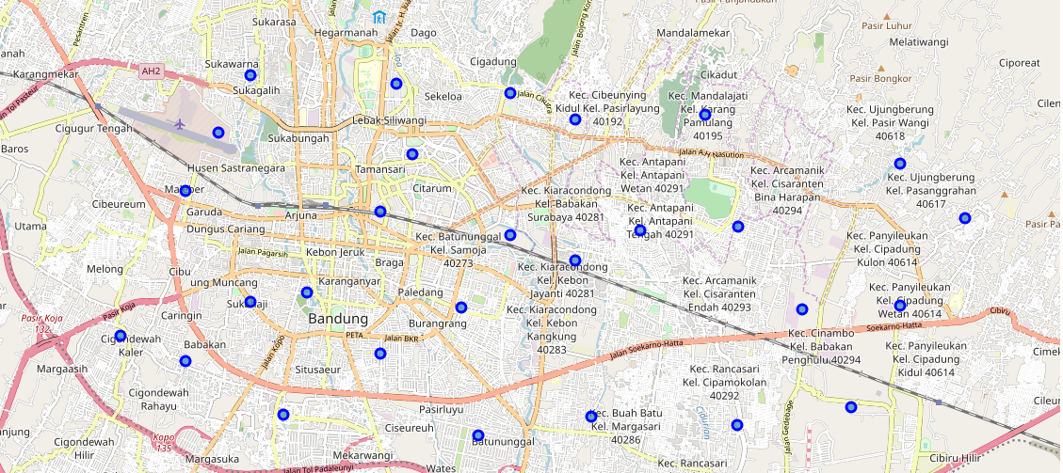

Image 1 Bandung City Map with Sub-District Location

I used the center of each sub-district and not an area of that sub-district because, it's currently impossible for now as I don't have the JSON File for each area of the sub-district or a choropleth map. That's why I choose the center point for each district, and then find the venues within a specific radius.

Here we find 10 sub-district with the highest population density.

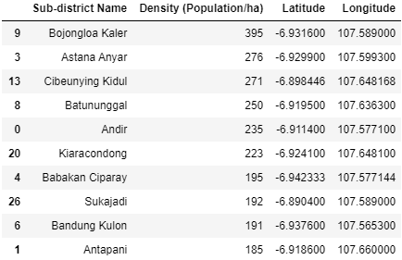

Image 2 Top 10 Population Density on Sub-District

The Sub-district with a highest population density is Bojongloa Kaler with 395 population/hectare, and the least from the top 10 is Antapani with 185 population / hectare. These sub-districts will be processed on its venues whether they have at least 10 venues nearby or not.

Here are the bar chart about venue amount on each sub-district. The x-axis is the sub-district, and the y-axis is the amount of venues on that sub-district.

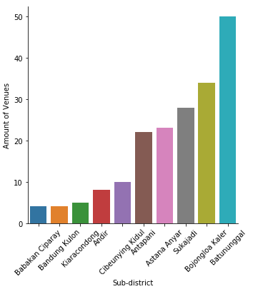

Image Amount of Venues on Sub-district

Some of these sub-district have less than 10 venues which are Babakan Ciparay, Bandung Kulon, Kiarancondong, and Andir. So there are only 6 sub-districts left. These are the best candidates on building an apartment.

There are the and least common venues in each sub-districts. Here is the table on common districts

Table Most and Least Common Venues on Sub-district

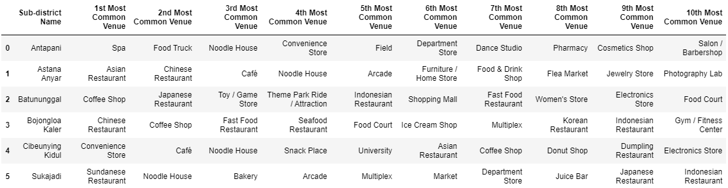

This table can be used on deciding which sub-district match our preference. Some venues may be preferred by the resident, and some may be not.

1. **Results**

After the analysis, now visualizing sub-district and venues on map.

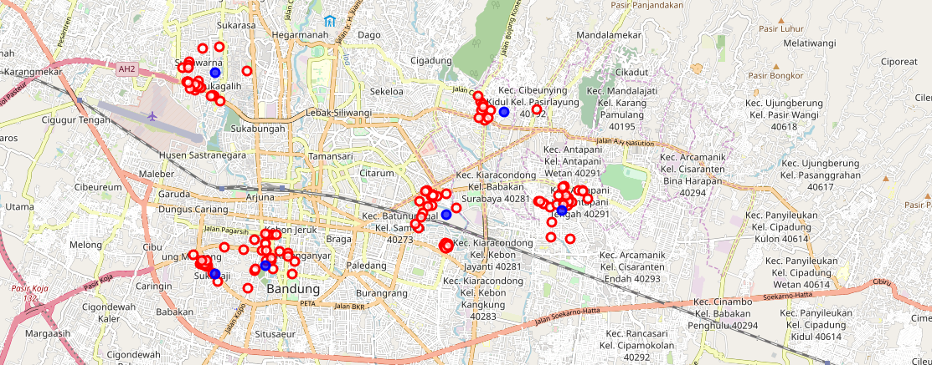

Image Best Sub-district And Venues

There are 6 best sub-districts to be built based on population density and amount of venues. But we need more information on similarities between sub-districts. This can be done using K-Means Clustering Algorithm.

The clustering needed *k* of clusters, which I choose to be 3. Features used for the clustering are venues proportion, population density, latitude, and longitude. These features needs to be rescaled using Robust Scaler from Scikit-learn library.

Here is the result after clustering

Table Clustered Sub-district

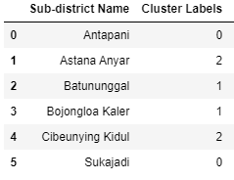

Here is the result on the map

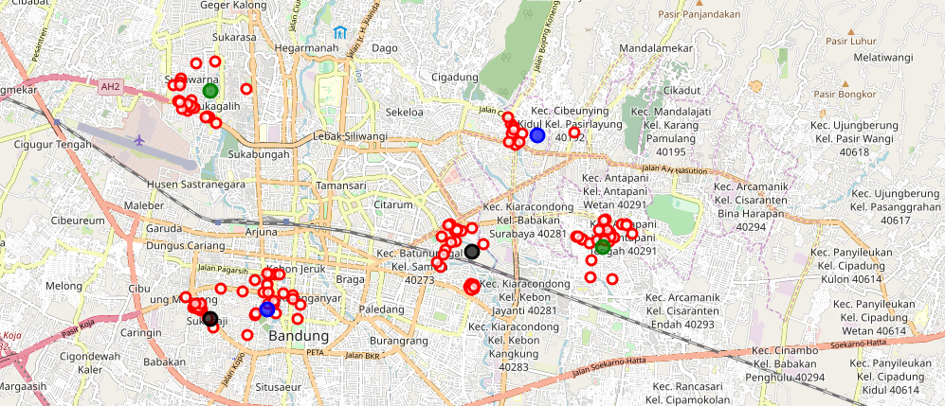

Image Clustered Sub-districts

1. **Discussion**

From the analysis I did, I filtered the sub-district based on their population density and venues. From a total of 30 sub-districts, there are 6 best sub-districts to become our best consideration when it comes to building an apartment. Of course, there could be added more features such as lands that are on sale, land pricing, specific transportation available in the nearby area, and the government's permission to build an apartment.

After I choose these candidates, I used K-Means Clustering Algorithm to see similarities between sub-districts based on its venues. For the cluster numbers, I choose 3 clusters just because I'd like to see the possible pair between sub-districts. Fortunately, there are 3 clusters with each cluster exactly have one pair. This would be an easier choice to build an apartment rather than choosing between 6 different sub-districts. These clusters meaning that inside on one cluster, 2 sub-districts are similar based on its venues, population density, latitude, and longitude.

1. **Conclusion**

If we build an apartment in these locations, it could suppress the population density problem that will occur in the future. Not only considering population density, these sub-district at least had 10 venues available nearby for 750 meters(according to Foursquare API) that at least these sub-districts are sufficient enough to fulfill the resident's needs. Hopefully, this insight can give you so many meaningful knowledge on finding the best location to build an apartment. Thank you for checking out on my notebook.